***Design thinking Assignment***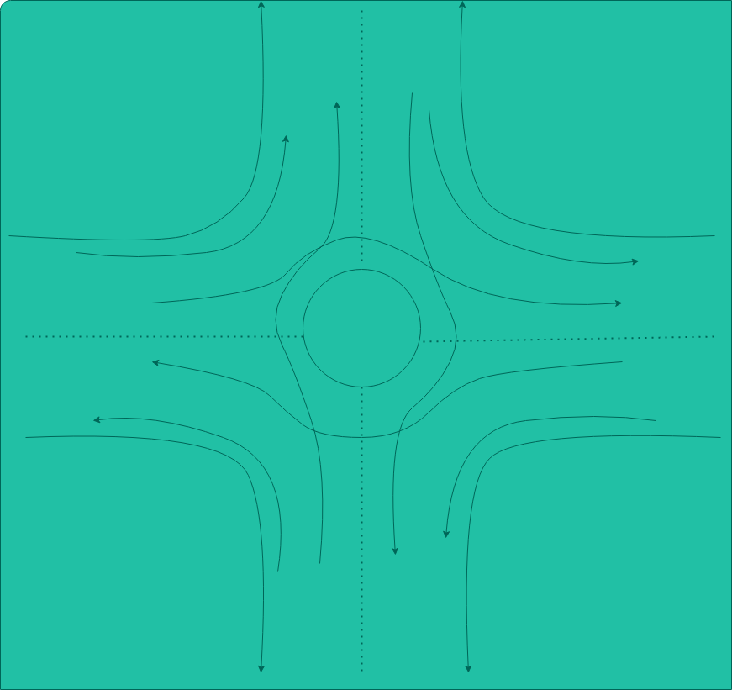

* Intersections are a critical aspect of street design as the point where motorist, bicycle, and pedestrian movements converge. Successful intersection design addresses all mobility and safety goals as well as opportunities to enhance the public realm. This section explores intersection design and operation, from signal timing to crosswalks, and investigates each concept as it relates to citywide goals for safety, mobility, and more vibrant, accessible public spaces.
* The above system is design base on assumption that the road intersection is for 1 lane vehicle flow and 2 roads are meet at perpendicular intersection. Given that there will be medium traffic flow at the intersection throughout the day.
* Problem with perpendicular intersection is that those are prone to accident very often. Around 15000+ accident occurs everyday in USA. While it is true that we cannot make any road or intersection accident proof but we can take simple measures to avoid such life-threatening issues.
* We can simply put solid concrete Circle at the centre which will represents a strong solid thing which will force driver to move through left of it.
* We can install security cameras, speed cameras, traffic signal, traffic controller booth in the circle so that it all will be safe to accidents.
* We can arrange a footpath and separate lane for bike and cyclist. Bus stop can be established at 100 m away from the intersection so that there will not be any conjunction.
* Visibility can be achieved through a variety of design strategies, including intersection “daylighting,” design for low-speed intersection approaches, and the addition of traffic controls that remove trees or amenities that impede standard approach, departure, and height sight distances.
* We can include Four phase signals systems for traffic control, where, flow from each approach is put into a single phase avoiding all conflicts. This type of phase plan is ideally suited in urban areas where the turning movements are comparable with through movements and when through traffic and turning traffic need to share same lane.
* We can include bumpers at just before the turns so that the vehicles will be force to slow down and thus will avoid speed crashes.
* This system reduces the accidents by 3 times less. In normal intersection there are 24 intersection points identified as shown in fig. below. (Fig taken from internet)

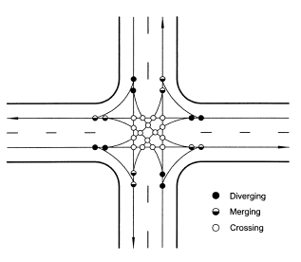

* The design reduces these 24 points to 8 points and thus the accidents are less likely to occur.
* Considering accident happens, the impact with not be at straight angle but in an inclination angle which can save life.
* Design a curve also reduces the speed of vehicle so that the impact may be not life threatening.
* In future other modifications can also be made like designing an underpass for pedestrians, giving separate lane for bikes cyclist and cars. Installing bumpers etc.
* If the roads need to be increase then, flyover system or cloverleaf intersection system can also be implemented which will avoid most of the traffic jams and accidents.